Sandown Wireless
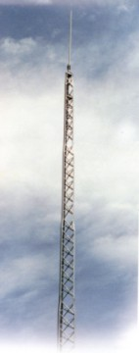
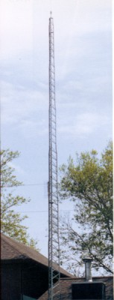
BX TOWER SERIES
- X Brace design for strength. Braces riveted in center as well as ends.
- All Riveted Construction.
- Greater width and weight at bottom.
- Beaded channel leg for added strength
- All steel.
- Pregalvanized for added life.
- Rotators easily installed.
- Three steps included on one face of top section.
Sections nest inside each other for compact shipment.

BX |  | HBX |  | HDBX
Standard  Basic Tower Needs |  | Heavy Duty  For Heavier Capacity |  | Extra Heavy Duty  Our Heaviest BX Tower
Maximum height 64' |  | Maximum height 56' |  | Maximum height 48'
Can be used with Concrete Base Stubs |  | Can be used with Concrete Base Stubs |  | Can be used with Concrete Base Stubs
Available in heights of 24' to 64' in 8' increments |  | Available in heights of 24' to 56' in 8' increments |  | Available in heights of 24' to 48' in 8' increments
Up to 6 square feet antenna capacity |  | Up to 12 square feet antenna capacity |  | Up to 20 square feet antenna capacity
Top of tower is a 8-1/8" triangle |  | Top of tower is a 10-3/16" triangle |  | Top of tower is a 12-3/4" triangle
Includes 8' mast (M8) |  | Mast not included |  | Mast not included
Always has #1 as a top section |  | Always has #2 as a top section |  | Always has #3 as a top section

For more information contact: Sandown Wireless
P.O. Box 564
East Hampstead, NH 03826
Toll Free: 866-379-8437 Fax: 603-887-2117
sales@criticaltowers.com www.criticaltowers.com
BX Tower Accessories
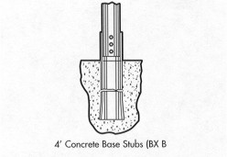 | 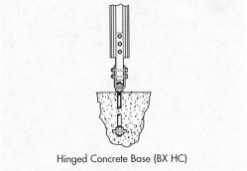
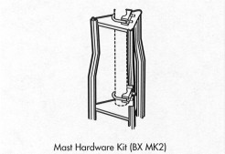 | 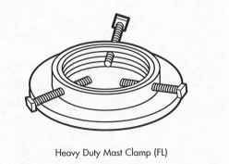
Sandown Wireless  P.O. Box 564  East Hampstead, NH 03826  Office: 603-425-9876  sales@criticaltowers.com  www.criticaltowers.com | 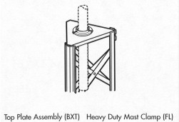

Tower packages - compact shipping and storage method. Includes all necessary parts and hardware.
All towers are recommended to be bracketed for extra safety and to withstand gusty wind conditions.
Note: Local building and / or zoning laws frequently require a building permit. Available BX Engineering Data should be submitted for approval prior to purchasing a tower.

BX TOWER

Part #
8’BX Sections

BX1A | Offset top section w/BXT1, BXR1, BXMK2 | 26#
BX2 | Standard offset section | 24#
BX2A | Offset top section w/BXT2, BXR2, FL | 31#
BX3 | Standard offset section | 29#
BX3A | Offset top section w/BXT3, BXR3, FL | 39#
BX4 | Standard offset section | 42#
BX5 | Standard offset section | 60#
BX6 | Standard offset section | 65#
BX7 | Standard offset section | 75#
BX8 | Standard offset section | 83#

Nuts and bolts are included in section prices.

BX Accessories

BXMK2 | Mast hardware kit w/rotor post for top and rotor plate | 2#
FL | Heavy duty mast clamp | 3#
TB3 | Heavy duty thrust bearing, recommended for 2” OD tubing (for use w/section 3 with field drilled hole) | 2 ½#
TB4 | Heavy duty thrust bearing, recommended for 3” OD tubing (for use w/section 3 with field drilled hole) | 3#
BXSM | Side mount (28”- 40”) w/4’, 1 ¼ ” OD mast (fits sections 1 thru 4) | 12#
BXSK1 | Extra step kit for section 1 (3 steps on one face) | 15#
BXSK2 | Extra step kit for section 2 (3 steps on one face) | 1#
BXSK3 | Extra step kit for section 3 (3 steps on one face) | 1#

Top and Rotor Plates

BXT1A | Top plate for section 1 w/hardware nuts, bolts, and ACWS | 2#
BXT2A | Top plate for section 2 w/hardware nuts, bolts, and ACWS | 2#
BXT3A | Top plate for section 3 w/hardware nuts, bolts, and ACWS | 2 ½#
BXR1A | Rotor plate for section 1 w/hardware nuts, bolts, and ACWS | 1 ½#
BXR2A | Rotor plate for section 2 w/hardware nuts, bolts, and ACWS | 2#
BXR3A | Rotor plate for section 3 w/hardware nuts, bolts, and ACWS | 2 ½#

Masts

M8 | 8’ mast (1 ¼”) | 6 ½#

BX TOWER

Part Number

Self-Supporting Standard BX w/(M8) 8’ Mast

BX24 | 24’ Standard Tower Assembly w/M8 (Order base stubs as a separate item) | 96#
BX32 | 32’ Standard Tower Assembly w/M8 (Order base stubs as a separate item) | 142#
BX40 | 40’ Standard Tower Assembly w/M8 (Order base stubs as a separate item) | 205#
BX48 | 48’ Standard Tower Assembly w/M8 (Order base stubs as a separate item) | 273#
BX56 | 56’ Standard Tower Assembly w/M8 (Order base stubs as a separate item) | 351#
BX64 | 64’ Standard Tower Assembly w/M8 (Order base stubs as a separate item) | 450#

Part Number

Self-Supporting Heavy Duty BX Tower w/(FL) Mast Clamp

HBX24 | 24’ Heavy Duty Tower Assembly (Order stubs as a separate item) | 143#
HBX32 | 32’ Heavy Duty Tower Assembly (Order stubs as a separate item) | 187#
HBX40 | 40’ Heavy Duty Tower Assembly (Order stubs as a separate item) | 254#
HBX48 | 48’ Heavy Duty Tower Assembly (Order stubs as a separate item) | 328#
HBX56 | 56’ Heavy Duty Tower Assembly (Order stubs as a separate item) | 419#

Part Number
Self-Supporting Extra Heavy Duty BX Tower w/(FL) Mast Clamp

HDBX24 | 24’ X-Heavy Duty Tower Assembly (Order stubs as a separate item) | 171#
HDBX32 | 32’ X-Heavy Duty Tower Assembly (Order stubs as a separate item) | 231#
HDBX40 | 40’ X-Heavy Duty Tower Assembly (Order stubs as a separate item) | 305#
HDBX48 | 48’ X-Heavy Duty Tower Assembly (Order stubs as a separate item) | 397#

Part Number
4’ Concrete Base Stubs (Set of 3)
(Tower height not to exceed 64 ft.)

BXB3 | Stubs for section 3 | 13#
BXB4 | Stubs for section 4 | 17#
BXB5 | Stubs for section 5 | 18#
BXB6 | Stubs for section 6 | 22#
BXB7/8 | Stubs for section 7 & 8 | 25#

Part Number
Self-Supporting Hinged Concrete Base for all Sections
(Tower height not to exceed 64 ft.)

BXHC36 | Fits sections 3 through 6 | 27#
BXHC78 | Fits sections 7 and 8 | 56#

MAST ASSEMBLY

BX – STANDARD / HBX – HEAVY DUTY / HDBX – EXTRA HEAVY DUTY TOWERS

1. Two U-bolt assemblies with “L” brackets are supplied for installing the mast. These “L” brackets are bolted through the slotted holes on the rotor and top plate with the short legs of the “L” bracket toward the outside of the tower. See Drawing C750429.

2. Run the U-bolt through the open side of the formed “V” clamp and into the “L” bracket placing the 5/16” nuts and washers on the U-bolt loosely.

3. To install the mast, place one end of it through the upper U-bolt assembly end plate and slide it down into the lower U-bolt assembly to hold the mast.

4. Adjustments to make the mast vertical may be made by moving the “L” brackets in the slotted holes.
The HDX – Heavy Duty and HDBX – Extra Heavy Duty Towers are furnished with a mast clamp installed on the top plate made from a pipe floor flange, which is provided with three bolts to be used as set screws to secure the mast. The box of hardware consists of one U-bolt assembly as described above and it can be installed on the lower plate as is instructed above, if required.

ASSEMBLY INSTRUCTIONS

BREAKING DOWN THE BUNDLE

1. If your tower includes the 8’ mast and/or three 4’ base stubs, remove them. Remove the package of nuts, bolts and washers.

2. Lay the bundle on its side and remove the tower sections. Start with the innermost section of the package (the smallest section) and remove by pulling out with quick, firm jerks. It is not necessary nor desirable to pry the tower sections out with tools as damage may result.

3. Inspect all tower sections on delivery to make sure there are no loose or broken rivets caused by transport mishandling. If a rivet is broken or loose, it should be replaced by a snug-fitting machine bolt and nut, securely tightened.

TOWER

After you have chosen the desired type of base for your tower (concrete base with BXB concrete base stubs, BXHC hinged concrete base, or BXCA cylinder base which hinges over and requires no concrete) and it is properly installed per base instructions, bolt the base section (the largest section) to the base. Proceed with the erection as follows:

1. The legs on each higher section slide inside the previous one and should be positioned on the rivet stop in the previous leg. (This rivet stop is to prevent the tower section being installed from slipping through the previous section and is not for the purpose of aligning the assembly holes.) (Special Note: the BX8 section does not have a rivet stop in it, so extreme caution should be used when installing the BX7 section into the BX8 section.) Proceed by bolting together each section with the proper size bolts.

2. To erect the tower, section by section vertically, you should use an EFBX erection fixture for raising and locating the section being installed into the previous section. (Note: do not use an erection fixture to lift more than the weight of one tower section at a time.) By using BXHC or BXCA base the tower can be assembled on the ground and hinged up using extreme caution. When hinging up, watch for power lines, trees, etc.

3. Loose, missing or faulty rivets should be replaced with a similar size nut and bolt which can be obtained at any local hardware.

Note: 3/8” bolts are used on BX1, BX2 and the top of the BX3 sections. 9/16” bolts are used on the bottom of the BX3 and all sections from BX4 through BX8 (BX8 is the largest section).

One set of cross braces on one face of the top section is purposely left off to allow easy access to the rotor plate for installing the mast and rotor. (Note: Only one person should be on the tower at one time.)

CAUTION…Be sure hinge bolts on hinged type accessories are loosened before attempting to hinge tower up or down. All hinged type bases are intended to be used to raise tower only without antenna. When raising and lowering tower on any hinged type base, the loads applied for raising the tower must be applied equally on both sides of the tower using a cradle or by using several attachment points in order to prevent overloading a tower member and to reduce the possibility of twist on the tower and hinges at the base. Special care must be taken to avoid the use of raising and lowering methods which cause damage to tower or base. Tower must be initially raised prior to applying tension to a hoisting line to avoid a large horizontal force pulling the tower into the base. Towers and bases must only be installed and dismantled by professional and experienced installers. Field welding is prohibited on tower, base and anchor bolts.

Be sure to check anchor bolt projections per drawing C760099R7. Make sure the anchor bolt is not interfering with the raising or lowering of the hinge pipe. Check this before attempting to hinge up or lower the tower.

NOTES ON ASSEMBLING ROTATORS

Most all makes of rotators can be installed on the rotor plate inside the top tower section of the BX standard, HBX, heavy duty, and HDBX extra heavy duty towers. There is a short piece of tubing furnished with each tower that can be used as a thrust bearing (for 1-1/4” mast) with the mast clamp installed on the top plate as is described under the heading Mast Assembly. Do not install rotators on the HDBX top plate.

For the HBX – Heavy Duty and HDBX 0 Extra Heavy Duty Towers, when a rotator is used a 4” piece of tubing or pipe with an I.D. larger than the O.D. of the mast can be installed in the pipe flange clamp and used as a bearing for the mast to turn in.

FOR ASSEMBLING THE ROTATOR ITSELF, FOLLOW THE PROCEDURES OUTLINED BELOW:

Some inline model rotators mount directly to the rotor plate. (The lower housing of the rotator is not used when this is done.) The necessary holes for mounting most rotors are pre-punched in the plate itself and the bolts furnished to bolt the lower housing to the upper housing (4-1/4” x 1” bolts) are to be inserted from the bottom of the plate upward and into the rotor. It is desirable to place 3/8” nuts to act as spacers between the rotor plate and the rotator.

These nuts will prevent the terminals of the rotator and the rotor wire from shorting on the rotor plate. An 8” piece of tubing is furnished with each tower. It can be installed into the clamp (“V” clamp and “L” shaped brackets furnished for offset rotor installation only) for the offset type rotors. It is necessary to reverse the clamp assembly (to face outside of the tower), opposite that of installing a standard mast to the rotor plate. Some rotators can be mounted directly to the “L” shaped bracket as shown or to the 8’ mast as previously described.

Also, some rotators mount beneath the rotor plate (as pictured). It will be necessary to increase the 1/4" holes in the rotor plate to 3/8” holes to use the 3/8” bolts furnished with these rotators. See pictorial views of typical rotor installations:

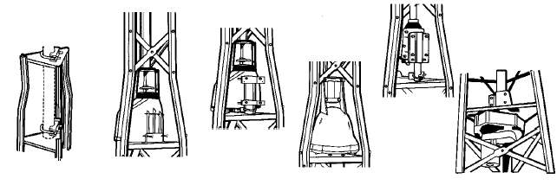

In all cases be careful during installation.

Notes:
Do not install towers near power lines. All towers should be installed out of falling distance of power lines since every electrical and telephone wire should be considered dangerous.

ROHN recommends anti-climb sections on all towers to prevent unauthorized persons from climbing towers. Only one person should be on the tower at a time.

All antenna installations must be grounded per local or national codes.

All towers should be installed and dismantled by experienced and trained personnel.

All types of antenna installations should be thoroughly inspected by qualified personnel at least twice a year and re-marked with hazard and warning labels to ensure safety and proper performance. A safety package (part number ACWS) is available which includes one anti-climb warning sign and two Danger – Watch for Wires labels along with other printed safety information.
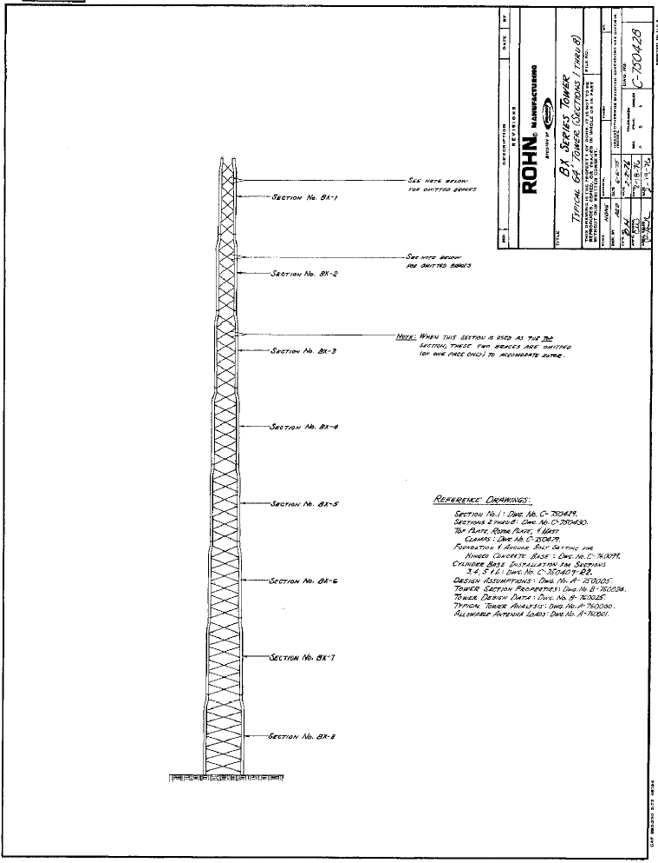
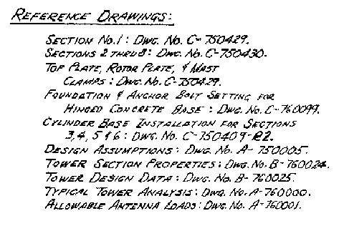
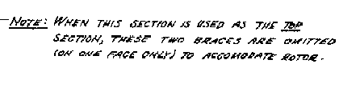
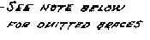

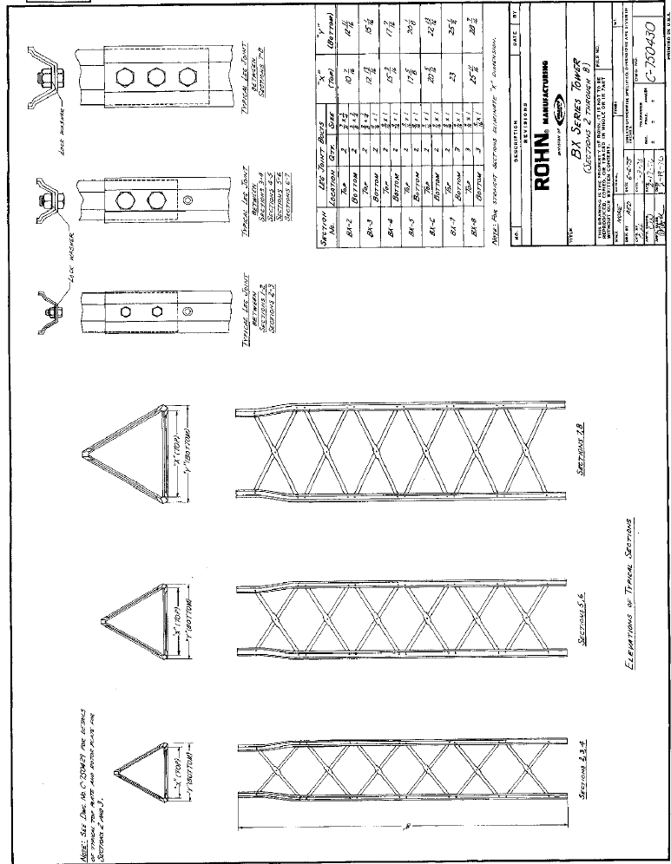
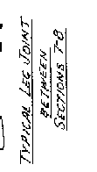
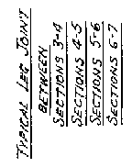
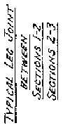
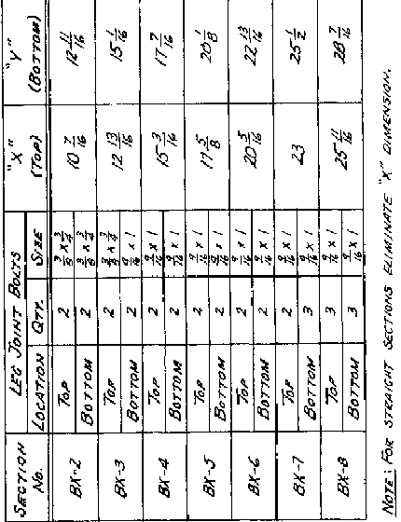
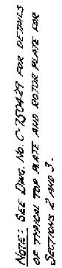
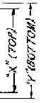
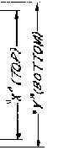
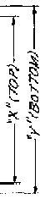
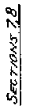
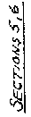
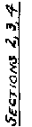
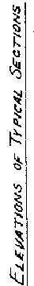
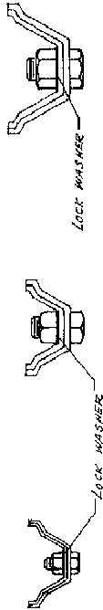
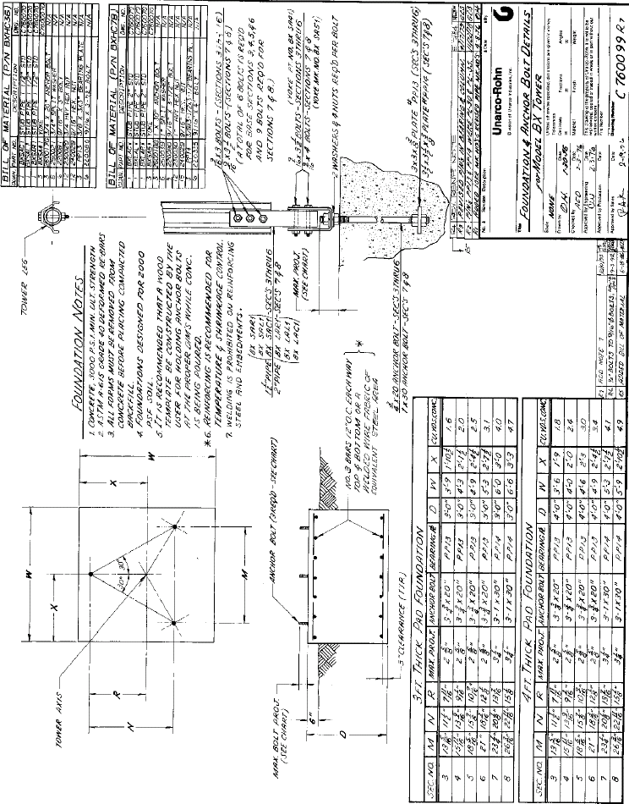

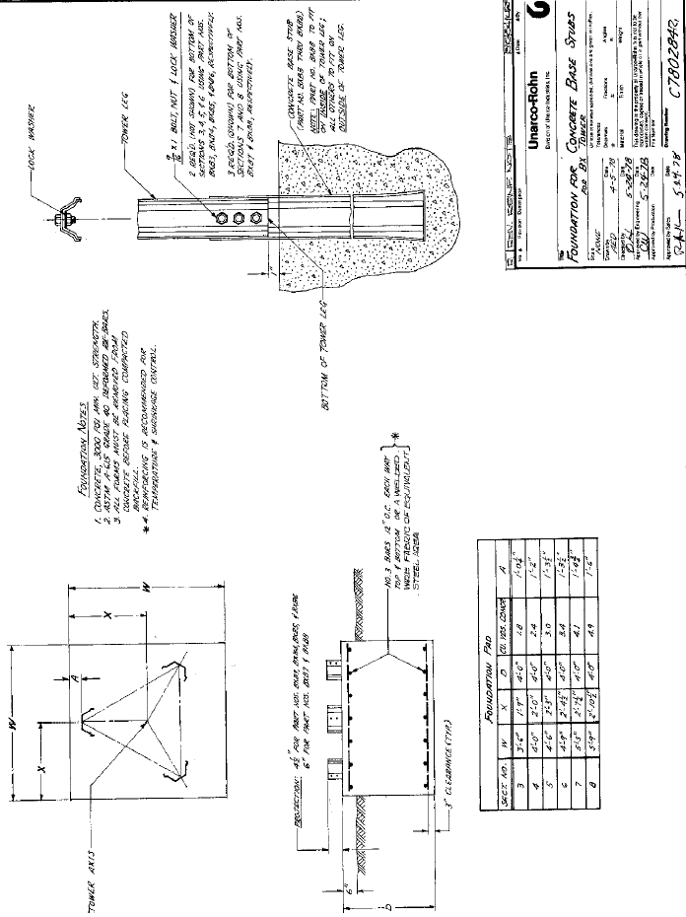
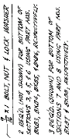
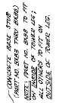
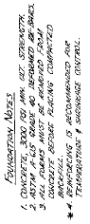
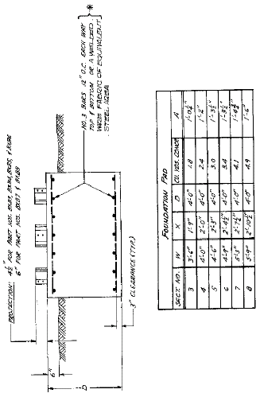
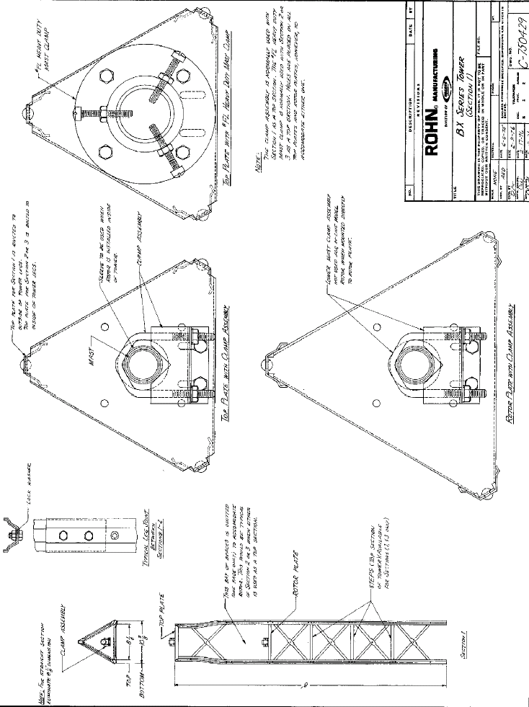
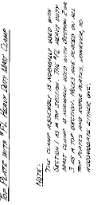
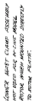
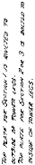
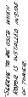
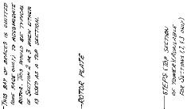
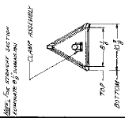
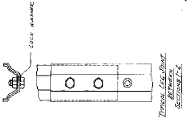
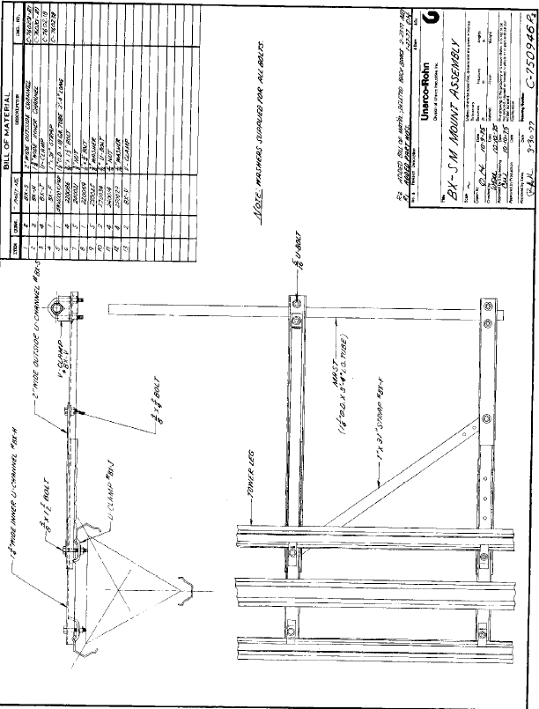
Typical Tower Analysis

Tower Design Data: Model BX-64
Wind Pressure ------ 20 PSF
Antenna Load --- 6 SQ.FT. at 3FT. above
Note: Antennas developing a large twisting Tower top – ½in. line
moment due to wind must not be used on Antenna WT. = 50 LBS.
This tower. Antennas should be limited Line WT. = 0.5 LBS. 1 FT.
to those having a maximum boom length of
10 FT.
Section No. | 8 | 7 | 6 | 5 | 4 | 3 | 2 | 1
Distance From Top (FT.) | 61.7 | 53.7 | 46.0 | 38.3 | 30.7 | 23.0 | 15.3 | 7.7
Wind on Section (LBS.) | 179.7 | 161.7 | 150.0 | 139.5 | 115.5 | 107.7 | 101.1 | 96.0
Wind on Antenna & Line (LBS.) | 5.5 | 5.3 | 5.3 | 5.3 | 5.3 | 5.3 | 5.3 | 127.4
Total Wind on Section (LBS.) | 185.2 | 167.0 | 155.3 | 144.8 | 120.4 | 113.0 | 106.4 | 223.4
Shear (LBS.) | 1215.9 | 1030.7 | 863.7 | 708.4 | 563.6 | 442.8 | 329.8 | 223.4
Moment (FT.-LBS.) | 37,770 | 28,790 | 21,530 | 15,500 | 10,620 | 6770 | 3810 | 1690
Face Width (FT.) | 2.284 | 2.047 | 1.824 | 1.602 | 1.381 | 1.184 | .989 | .794
.866 x Face Width (FT.) | 1.978 | 1.773 | 1.580 | 1.388 | 1.196 | 1.025 | .856 | .688
Leg Load (LBS.) ⁽¹⁾ | 19,100 | 16,240 | 13,630 | 11,170 | 8880 | 6600 | 4450 | 2460
Section Weight (LBS.) | 82 | 75 | 64 | 59 | 41 | 28 | 23 | 22
Total Weight (LBS.) | 476 | 390 | 312 | 244 | 181 | 136 | 104 | 77
*Leg Load with Weight (LBS.) | 19,260 | 16,370 | 13,730 | 11,250 | 8940 | 6650 | 4490 | 2480
Shear One Face (LBS.) ⁽²⁾ | 815 | 691 | 579 | 475 | 378 | 297 | 221 | 150
COS ∅ | .904 | .883 | .858 | .827 | .783 | .733 | .667 | .580
* Load Each Brach (LBS.) ⁽³⁾ | 451 | 391 | 337 | 287 | 241 | 203 | 166 | 129
- Leg Load = Moment .
.866 x Face Width

- Shear One Face = .67 x Shear

(3) Load Each Brace = Shear One Face ∅
2 x COS ∅

*Refer to DWG. No. B-760025 for allowable loads of members & connections.

Model BX Tower
Allowable Antenna Loads *
Wind Pressure = 20 PSF (70.7 MPH)
Nominal Height, FT. | Combination of Tower Sections | Catalog No. | Area, SQ.FT. | Thrust, LBS.
24 | BX-1-2-3 | BX-24 | 6 | 120
24 | BX-2-3-4 | HBX-24 | 12 | 240
24 | BX-3-4-5 | HDBX-24 | 20 | 400
32 | BX-1-2-3-4 | BX-32 | 6 | 120
32 | BX-2-3-4-5 | HBX-32 | 12 | 240
32 | BX-3-4-5-6 | HDBX-32 | 18 | 360
40 | BX-1-2-3-4-5 | BX-40 | 6 | 120
40 | BX-2-3-4-5-6 | HBX-40 | 10 | 200
40 | BX-3-4-5-6-7 | HDBX-40 | 18 | 360
48 | BX-1-2-3-4-5-6 | BX-48 | 6 | 120
48 | BX-2-3-4-5-6-7 | HBX-48 | 10 | 200
48 | BX-3-4-5-6-7-8 | HDBX-48 | 18 | 360
56 | BX-1-2-3-4-5-6-7 | BX-56 | 6 | 120
56 | BX-2-3-4-5-6-7-8 | HBX-56 | 10 | 200
64 | BX-1-2-3-4-5-6-7-8 | BX-64 | 6 | 120
* This load can be applied at a point of 3ft. above the apex of the tower in addition to the given wind pressure acting on the tower.

Note: Antenna types should be limited to those having a maximum boom length of 10 feet. No engineering data relating to the use of boom lengths in excess of 10 feet is available and the use of such boom lengths is not recommended.
DEG. NO. A-760001 _{Rl}

BX Tower

Tower As Packaged for Shipping |  |  |  |  |  |  |  |  |  |  |  |  |  | Optional Accessories
Tower Model |  | BX1A | BX2 | BX2A | BX3 | BX3A | BX4 | BX5 | BX6 | BX7 | BX8 | M8 | ACWS | BXB3 | BXB4 | BXB5 | BXB6 | BXB7 | BXB8 | BXHC36 | BXHC78 | BXSM
BX | 24 | X | X |  | X |  |  |  |  |  |  | X | X | X |  |  |  |  |  | X |  | X
BX | 32 | X | X |  | X |  | X |  |  |  |  | X | X |  | X |  |  |  |  | X |  | X
BX | 40 | X | X |  | X |  | X | X |  |  |  | X | X |  |  | X |  |  |  | X |  | X
BX | 48 | X | X |  | X |  | X | X | X |  |  | X | X |  |  |  | X |  |  | X |  | X
BX | 56 | X | X |  | X |  | X | X | X | X |  | X | X |  |  |  |  | X |  |  | X | X
BX | 64 | X | X |  | X |  | X | X | X | X | X | X | X |  |  |  |  |  | X |  | X | X
HBX | 24 |  |  | X | X |  | X |  |  |  |  |  | X |  | X |  |  |  |  | X |  | X
HBX | 32 |  |  | X | X |  | X | X |  |  |  |  | X |  |  | X |  |  |  | X |  | X
HBX | 40 |  |  | X | X |  | X | X | X |  |  |  | X |  |  |  | X |  |  | X |  | X
HBX | 48 |  |  | X | X |  | X | X | X | X |  |  | X |  |  |  |  | X |  |  | X | X
HBX | 56 |  |  | X | X |  | X | X | X | X | X |  | X |  |  |  |  |  | X |  | X | X
HDBX | 24 |  |  |  |  | X | X | X |  |  |  |  | X |  |  | X |  |  |  | X |  | X
HDBX | 32 |  |  |  |  | X | X | X | X |  |  |  | X |  |  |  | X |  |  | X |  | X
HDBX | 40 |  |  |  |  | X | X | X | X | X |  |  | X |  |  |  |  | X |  |  | X | X
HDBX | 48 |  |  |  |  | X | X | X | X | X | X |  | X |  |  |  |  |  | X |  | X | X

NOTE: Be sure you select type of base and ORDER SEPARATELY for BX, HBX, and HDBX towers.

CAUTION…..AX hardware is not interchangeable with BX hardware.

All types of antenna installations should be thoroughly inspected by qualified personnel at least twice a year and re-marked with hazard and warning labels to insure safety and proper performance.

SPECIFICATIONS SUBJECT TO CHANGE WITHOUT NOTICE.

Model BX Tower Design Assumptions

Tower Material Specifications:
Legs: ASTM A-446 Grade C Steel (Minimum Yield Point – 45,000 PSI)
(Galvanized according to ASTM A-525)
Braces: Cold Rolled C-1017 Steel (Minimum Yield Point – 36,000 PSI)
(Galvanized according to ASTM A-525)
Leg Splice Bolts: SAE Grade 5 Steel
Rivets: 2017-T4 Aluminum Alloy

Tower Member Allowable Design Stresses:
Note: Allowable stresses below have been increased
by 33 1/3% for the wind load condition. ⁽¹⁾

Legs:
Compression (Stress varies according to slenderness ration) ⁽²⁾
Bearing 126,000 PSI ⁽³⁾
Shear 24,000 PSI ⁽⁴⁾

Braces:
Compression (Stress varies according to slenderness ration) ⁽²⁾
Bearing 100,800 PSI ⁽³⁾
Shear 19,330 PSI ⁽⁴⁾

Bolts:
Shear 29,300 PSI (Threads excluded from shear plane) ⁽⁵⁾

Rivets:
Shear 18,120 PSI ⁽⁶⁾
Bearing 53,400 PSI ⁽⁶⁾

⁽¹⁾ PAR.3.1.2.1 of A.I.S.I. “Specification for the Design of Cold-
Formed Steel Structural Members”, 1968 Edition.
⁽²⁾ A.I.S.C. Manual of Steel Construction, 7th Edition, Pgs. 5.84 & 5.86.
⁽³⁾ PAR.4.5.3 of A.I.S.I. Specifications, 1968 Edition.
⁽⁴⁾ A.I.S.C. Manual of Steel Construction, 7th Edition, Pg. 5.64.
⁽⁵⁾ PAR 4.5.5 of A.I.S.I. Specifications, 1968 Edition.
⁽⁶⁾ Aluminum Construction Manual, “Specifications for Aluminum
Structures”, 1967 Edition.

Tower Shape Factors:
Individual Members (Legs, Braces, Transmission Lines)
Shape Factor: 1.00 for Flat Elements
.67 for Cylindrical Elements

Tower Section:
Shape Factor: 1.50 Times the projected area of
individual members in one face.

DWG. No. A-750005

Model BX Tower Section Properties
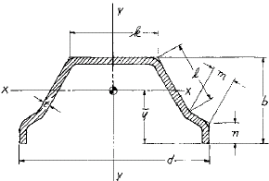 | Section Properties of Vertical Elements
 | Sect. | t  in. | b  in. | d  in. | k  in. | l  in. | m  in. | n  in. | Area₁  in.^{I} | ч  in. | Ix  in.⁴ | Tx  in. | Iy  in. | Ty  in.
 | BX-1 | .048 | 1.1742 | 2.0984 | .7500 | 1.0134 | .1934 | .1999 | .1637 | .6890 | .0236 | .380 | .0746 | .675
 | BX-2 | .048 | 1.1887 | 2.2145 | .8286 | 1.0198 | .2114 | .1999 | .1698 | .7052 | .0256 | .388 | .0862 | .712
 | BX-3 | .060 | 1.2151 | 2.3544 | .9210 | 1.0298 | .2330 | .2068 | .2228 | .7233 | .0346 | .394 | .1260 | .752
 | BX-4 | .085 | 1.2596 | 2.5441 | 1.0422 | 1.0476 | .2623 | .2212 | .3296 | .7511 | .0548 | .408 | .2156 | .809
 | BX-5 | .1008 | 1.3058 | 2.7661 | 1.1818 | 1.0704 | .2967 | .2305 | .4151 | .7863 | .0742 | .423 | .3172 | .874
 | BX-6 | .1008 | 1.3428 | 2.9881 | 1.3216 | 1.0932 | .3311 | .2305 | .4407 | .8160 | .0838 | .436 | .3926 | .944
 | BX-7 | .1158 | 1.3946 | 3.2399 | 1.4784 | 1.1206 | .3700 | .2391 | .5384 | .8522 | .1106 | .453 | .5594 | 1.019
 | BX-8 | .1158 | 1.5780 | 3.4916 | 1.6354 | 1.1480 | .4089 | .3794 | .6043 | .9769 | .1540 | .505 | .7810 | 1.137

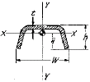 | Section Properties of Diagonal Elements |  |  |  |  |  |  |  |  |  |  | Section Properties of Tower
 | Sect. | t  in. | h  in. | w  in. | Area₁  in.² | ч  in. | Ix  in.⁴ | Tx  in. | Iy  in.⁴ | 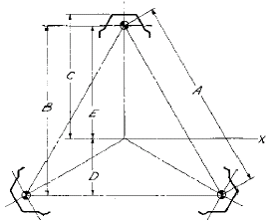  Ty  in. |  | Sect. | Area  (3 legs)  in.² | A  in. | B  in. | C  in. | D  in. | E  in. | Ix  in.⁴ | Tx  in. | Weight,  LBS.
 | BX-1 | .048 | .35 | .75 | .054 | .235 | .000620 | .107 | .00330 | .247 |  | BX-1 | .491 | 9.53 | 8.25 | 5.99 | 2.75 | 5.50 | 7.50 | 3.91 | 22
 | BX-2 | .048 | .35 | .75 | .054 | .235 | .000620 | .107 | .00330 | .247 |  | BX-2 | .509 | 11.86 | 10.27 | 7.33 | 3.42 | 6.85 | 12.03 | 4.86 | 23
 | BX-3 | .048 | .35 | .75 | .054 | .235 | .000620 | .107 | .00330 | .247 |  | BX-3 | .668 | 14.50 | 12.30 | 8.69 | 4.10 | 8.20 | 22.58 | 5.81 | 28
 | BX-4 | .060 | .35 | .75 | .0675 | .228 | .000732 | .104 | .00394 | .242 |  | BX-4 | .989 | 16.58 | 14.35 | 10.08 | 4.78 | 9.57 | 45.44 | 6.78 | 41
 | BX-5 | .075 | .46 | 1.05 | .1125 | .307 | .002164 | .139 | .01342 | .345 |  | BX-5 | 1.245 | 19.23 | 16.65 | 11.62 | 5.55 | 11.10 | 76.94 | 7.86 | 59
 | BX-6 | .075 | .46 | 1.05 | .1125 | .307 | .002164 | .139 | .01342 | .345 |  | BX-6 | 1.322 | 21.89 | 18.96 | 13.16 | 6.32 | 12.64 | 105.9 | 8.95 | 64
 | BX-7 | .075 | .46 | 1.05 | .1125 | .307 | .002164 | .139 | .01342 | .345 |  | BX-7 | 1.615 | 24.56 | 21.27 | 14.72 | 7.09 | 14.18 | 162.7 | 10.04 | 75
 | BX-8 | .075 | .46 | 1.05 | .1125 | .307 | .002164 | .139 | .01342 | .345 |  | BX-8 | 1.813 | 27.41 | 23.73 | 16.42 | 7.91 | 15.82 | 227.4 | 11.20 | 82

Model BX Tower Design Data
Sect | Projected Areas |  |  |  |  |  |  |  |  | Wind Load Per Sect., LBS. |  |  | Allowable loads for  Vertical Leg Splices |  |  |  | Allowable Loads at  Diagonal Connections
Sect | Vertical Legs |  |  |  | Diagonals |  |  | Totals |  | At Wind Pressure of
Sect | Exposed  Width  (1Leg)  in. | Length,  in. | Exposed  Area  (1 Leg)  FT.² | Exposed  Area  (1 Leg)  FT.² | Width  in. | Total  Exposed  Length  (1 Face)  in. | Exposed  Area  (1 Leg)  FT.² | Total  Exposed  Length  (1 Face)  FT.² | Total  Exposed  Section  Area  Ft.² | 10 PSF | 15 PSF | 20 PSF | Splice  Bolts |  | Thick.  of Leg,  in. | Allowable  Tensile  Leg Splice  Capacity  LBS. | Rivet Dia., in. | Thick.  of  Brace,  in. | Area  In.² |  | Allow.load,  LBS.
 |  |  |  |  |  |  |  |  |  |  |  |  | No. | Dia. |  |  |  |  | BRG. | Shear | BRG. | Shear
BX1 | 1.73 | 96 | 1.15 | 2.30 | .75 | 173.4 | .90 | 3.20 | 4.800 | 48.0 | 72.0 | 96.0 | 2 | 3/8 | .048 | 5630 | 5/32 | .048 | .0075 | .0192 | 400 | 348
BX2 | 1.79 | 96 | 1.19 | 2.38 | .75 | 190.5 | .99 | 3.37 | 5.055 | 50.6 | 75.8 | 101.1 | 2 | 3/8 | .048 | 5810 | 5/32 | .048 | .0075 | .0192 | 400 | 348
BX3 | 1.87 | 96 | 1.25 | 2.50 | .75 | 209.2 | 1.09 | 3.59 | 5.385 | 53.9 | 80.8 | 107.7 | 2 | 9/16 | .060 | 7320 | 5/32 | .048 | .0075 | .0192 | 400 | 348
BX4 | 1.99 | 96 | 1.33 | 2.66 | .75 | 229.0 | 1.49 | 2.85 | 5.775 | 57.8 | 86.6 | 115.5 | 2 | 9/16 | .085 | 10,910 | 3/16 | .060 | .0112 | .0276 | 598 | 500
BX5 | 2.12 | 96 | 1.41 | 2.82 | 1.05 | 251.6 | 1.83 | 4.65 | 6.975 | 69.9 | 104.6 | 139.5 | 2 | 9/16 | .1008 | 13,870 | 1/4 | .075 | .0187 | .0491 | 1000 | 890
BX6 | 2.24 | 96 | 1.49 | 2.98 | 1.05 | 276.6 | 2.02 | 5.00 | 7.500 | 75.0 | 112.5 | 150.0 | 2 | 9/16 | .1008 | 14,880 | 1/4 | .075 | .0187 | .0491 | 1000 | 890
BX7 | 2.39 | 96 | 1.59 | 3.18 | 1.05 | 303.8 | 2.21 | 5.39 | 8.085 | 80.9 | 121.3 | 161.7 | 3 | 9/16 | .1158 | 18,340 | 1/4 | .075 | .0187 | .0491 | 1000 | 890
BX8 | 2.65 | 96 | 1.77 | 3.54 | 1.05 | 335.6 | 2.45 | 2.99 | 8.985 | 89.9 | 134.8 | 179.7 | 3 | 9/16 | .1158 | 20,910 | 1/4 | .075 | .0187 | .0491 | 1000 | 890

Allowable Compressive Loads
Sect | Vertical Legs |  |  |  |  |  |  | Diagonal Braces
Sect | Lv  in. | Ty  in. | Lv  Ty | F’a  PSI | Fa  PSI | Gross-  Sect  Area  (1 Leg)  in.² | Allowable  Leg Load,  LBS. | Lo  in. | To  in. | L’o  Ty  * | F’a  PSI | Fa  PSI | Gross-  Sect  Area  in.² | Allowable  Brace Load,  LBS.
BX1 | 12 ½ | .380 | 32.9 | 24,300 | 32,400 | .1637 | 5300 | 15.34 | .107 | 71.7 | 16,250 | 21,660 | .054 | 1170
BX2 | 12 ½ | .388 | 32.2 | 24,380 | 32,500 | .1698 | 5520 | 16.78 | .107 | 78.4 | 15,540 | 20,720 | .054 | 1120
BX3 | 12 ½ | .394 | 31.7 | 24,430 | 32,570 | .2228 | 7260 | 18.41 | .107 | 86.0 | 14,670 | 19,560 | .054 | 1060
BX4 | 12 ½ | .408 | 30.6 | 24,540 | 32,710 | .3296 | 10,780 | 20.16 | .104 | 96.9 | 13,360 | 17,810 | .0675 | 1200
BX5 | 12 ½ | .423 | 29.6 | 24,650 | 32,870 | .4151 | 13,640 | 22.22 | .139 | 79.9 | 15,370 | 20,490 | .1125 | 2310
BX6 | 12 ½ | .436 | 28.7 | 24,740 | 32,990 | .4407 | 14,540 | 24.41 | .139 | 87.8 | 14,560 | 19,410 | .1125 | 2180
BX7 | 12 ½ | .453 | 27.6 | 24,850 | 33,130 | .5384 | 17,840 | 26.66 | .139 | 95.9 | 13,490 | 17,990 | .1125 | 2020
BX8 | 12 ½ | .505 | 24.8 | 25,130 | 33,510 | .6043 | 20,250 | 29.19 | .139 | 105.0 | 12,330 | 16,440 | .1125 | 1850
*L’o=1/2Lo

Sandown Wireless
P.O. Box 564
East Hampstead, NH 03826
Office: 603-425-9876
sales@criticaltowers.com
www.criticaltowers.com

