BX GINPOLE & BASE PULLEY

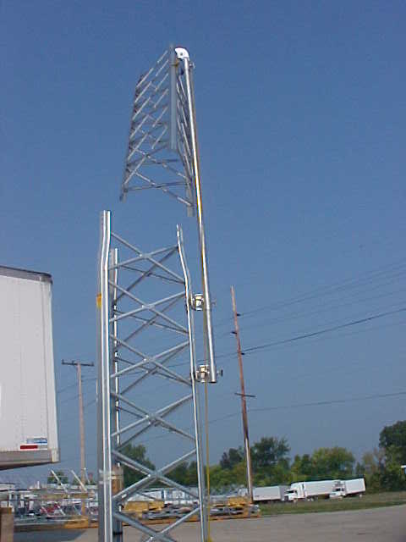
Sandown Wireless
P.O. Box 564
East Hampstead, NH 03826

Office: 603-425-9876

Direct E-mail: wa1hzk@usa.net
sales@criticaltowers.com

The BX GinPole consists of three basic parts:

- Pulley Assembly at the Top
- A pole 10 to 12 feet long and 2” outside diameter
- Clamps to attach to the BX Tower

Part Numbers:

GP2BX Head & Two Clamps $
BX GinPole 10’ Pole $

BX Ginpole Manufacture’s recommendations:

To erect a tower, first install a tower section in concrete pad or in concrete per tower manufactures recommendation and attach the ginpole on the upper part of this section.
Feed a rope through the pulley and pipe, attach the rope to next section of tower (above mid point of this section), pull it up over bottom section, install and secure with attaching bolts. Repeat this procedure until tower is erected. The use the ginpole to lift the mast, rotor and antennas into place make sure rope is properly attached to anything being lifted by ginpole. The pulle assembly can be adjusted any height desired at the clamp position with the thumbscrew.

Always pull the load up againt the side of the tower to minimize the stress on the tower and ginpole assembly. When a high lifting angle is used to raise the load(to clear obstructions, ect.) the stress put on the tower, ginpole and lift line become severe and possibly uncontrollable. This method is dangerous and may cause equipment failure. Towers in vicinity of power line are dangerous and should avaoided at all cost. The use of power winch or a vehicle is used to supplying the force becomes excessive and failure of the tower, ginpole or the lift line occurs. Ginpole kits are designed to lift using human power and should never be used with any type of mechanical power. Proper usage of gnple provides for a controllable and safer method to erect a tower and antenna assembly.
Refer to your tower manufacturer recommendations for guying as you are installing the tower.

