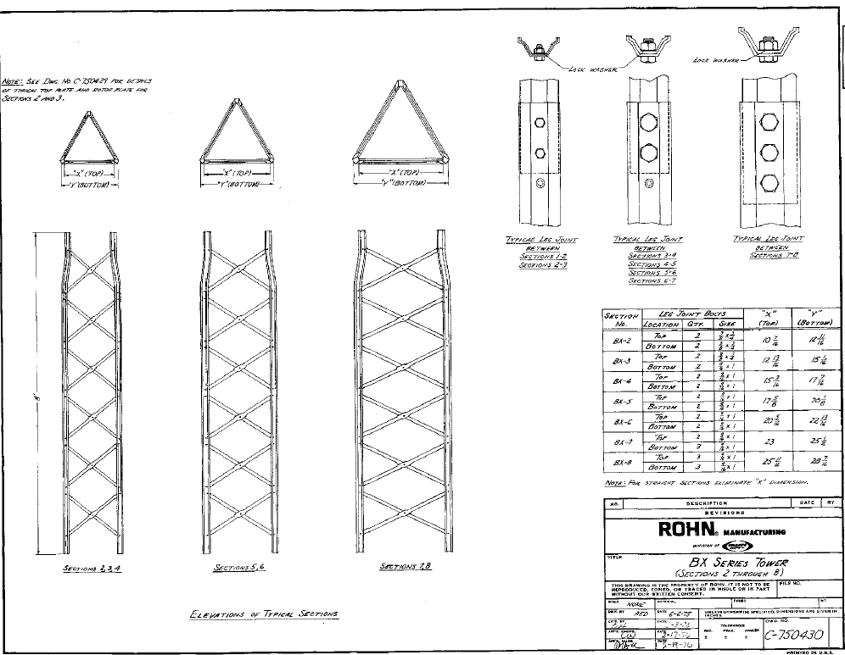
8’
Sections 2, 3, 4
Sections 5 & 6
Sections 7 & 8
Typical Sections

Elevations of Typical Sections
Sandown Wireless, USA

P.O. Box 564
East Hampstead, NH 03826
Office: 603-425-9876
Direct E-mail: wa1hzk@usa.net

sales@criticaltowers.com
www.criticaltowers.com

To Install BX Anti Climb Panels
- Position one side of a panel into the edge between the leg and the braces.
- Bow the panel to allow the opposite side to slide between the leg and braces on the opposite side.
- Position the panel so the retainer tabs are 1 above and 1 below the center of each cross brace.
- Bend retainer tabs in at 90° and insert retainer pin in back of braces.
7’
Anti-Climb Panel
Retainer Rod

